**E4KIDS**

**LIBRARY**

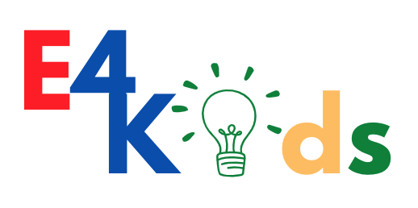

**Enhancing entrepreneurial mindset and self-empowerment in kids - EMPOW4KIDS**

*ERASMUS+ KA220-SCH - Cooperation partnerships in school education*

*2021-1-CZ01-KA220-SCH-000032484*

Author(s):

FAKULTNÍ ZAKLADNI SKOLA S RVJ PRI PEDF UK PRAHA 5 DRTINOVA

VÝZKUMNÝ ÚSTAV PRO PODNIKÁNÍ A INOVACE, Z.Ú.

SMART NEST

FORMATIVE FOOTPRINT

ECECE

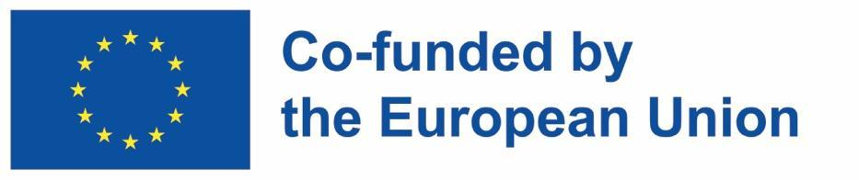

Funded by the European Union. Views and opinions expressed are however those of the author(s) only and do not necessarily reflect those of the European Union or the European Education and Culture Executive Agency (EACEA). Neither the European Union nor EACEA can be held responsible for them

**Project Acronym:**

EMPOW4KIDS

**Project Title:**

Enhancing entrepreneurial mindset and self-empowerment in kids

**Project Number:**

2021-1-CZ01-KA220-SCH-000032484

**Sub-programme or KA:**

KA220-SCH - Cooperation partnerships in school education

**Website**: <https://www.kidsentrepreneurs.eu>

**Consortium:**

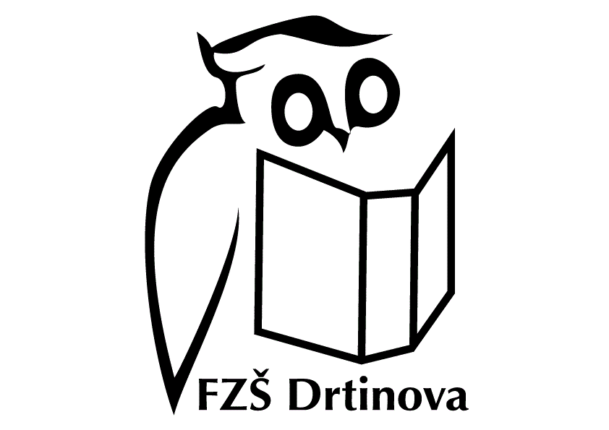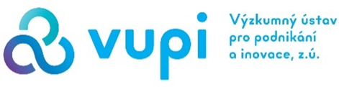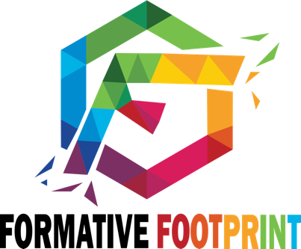

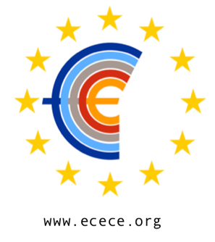

# LIBRARY

Useful links to be used be teachers

**WHAT PART (where to start)**

*Videos (what is it to be an entrepreneur):*

[Cha-Ching - Entrepreneur](https://www.youtube.com/watch?v=73IetI9oG20)(3:00)

[Innoventure Jr.: What is an entrepreneur?](https://www.youtube.com/watch?v=Sc-yHMF7mNo) **(**1:22)

[Does your child know what an entrepreneur is? - SmartKids](https://www.youtube.com/watch?v=PFx_dUGJI9M) (1:30 min)

[What Does It Mean To Be An Entrepreneur? ~ kids books read aloud](https://www.youtube.com/watch?v=_rtonlC8DGo) (9:55 min)

*Videos (young entrepreneur examples):*

[Young Entrepreneurs Share Their Success Story | Motivational Video for Kids](https://www.youtube.com/watch?v=XQ4RESzO2wI) (4:29 min)

[Child entrepreneurs turning ideas into money making businesses | A Current Affair](https://www.youtube.com/watch?v=UD_o3U4YAbU) (2:35 min)

[Live in the D: These Kids Have Their Own Business](https://www.youtube.com/watch?v=4tunmVhM2LA)(4:42 min)

**GENERAL INTRODUCTION TO THE BUSINESS PLAN / BUSINESS CANVAS**

[Writing a Business Plan](https://www.youtube.com/watch?v=7ykkhepT9aE)(3:43 min)

**Business Model Generation: A Handbook For Visionaries, Game Changers, and Challengers** - Osterwalder, Alexander; Pigneur, Yves; Clark, Tim (2010).. Strategyzer series. Hoboken, NJ

<https://www.canva.com/graphs/business-model-canvas/> - The free templates from Canva’s online business model canvas creator – © 2023 All Rights Reserved, Canva

**How to Pitch a Brilliant Idea** - Kimberly D. Elsbach [https://hbr.org/2003/09/how-to-pitch-a-brilliant-idea] - Harvard Business Review, September 2003

**How to effectively pitch a business idea** - Lauren Landry [https://online.hbs.edu/blog/post/how-to-pitch-a-business-idea] - Harvard Business School Online's Business Insights Blog, July 28, 2023

**WHO PART**

*Videos***:**

[Understanding customers types (Personas)](https://www.youtube.com/watch?v=kiiBhN69b7M) **(1:11)**

[What is Empathy Mapping?](https://www.youtube.com/watch?v=DfSuOkgv7BU) **(0:48)**

[Marketing Segmentation](https://www.youtube.com/watch?v=DUuirqtSqpg) **(3:42)**

[Consumers vs Customers: What is the difference?](https://www.youtube.com/watch?v=XH-9md0PaFk) **(1:02)**

[Introduction To Marketing For Kid Entrepreneurs](https://www.youtube.com/watch?v=a7VIINhlTwU) **(1:08 min)**

**HOW PART**

**HOW MUCH PART**

<https://kidentrepreneurship.com> – The free Entrepreneurship Education for K-12 schools & families

<https://www.youtube.com/@Kidspreneurship> – The YouTube channel to give an easy understanding of the journey starting a business venture.

**Kidpreneur$. Young entrepreneurs with big ideas** - Matthew & Adam Toren - 2023 - Real World Lessons JV DBA

<https://bizkids.com> - Biz Kid$ is a U.S. national financial literacy initiative based on the Emmy Award-winning public television series where kids teach kids about money and business - © 2023 Biz Kids, LLP